Weka-introduction

**Weka** is a free software tool for data mining and machine learning. It provides a user-friendly interface to help you analyze data and build predictive models without needing to write code. It’s used for tasks like classification, regression, clustering, and finding patterns in data.

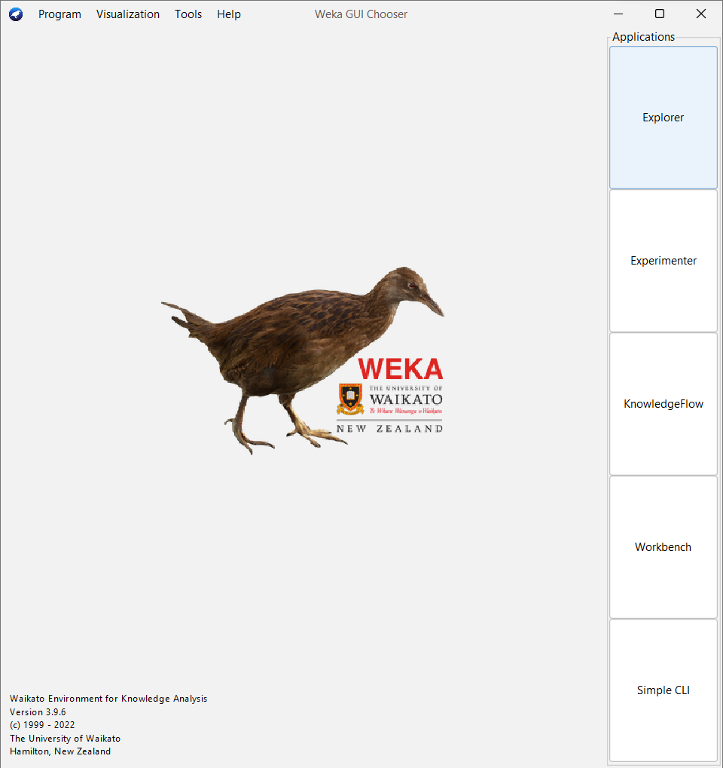

Explorer in weka

The **Explorer** in Weka is a key graphical user interface (GUI) that simplifies the process of exploring, analyzing, and modeling data. It’s designed to help users interact with their data and machine learning algorithms in a straightforward, visual manner.

**Use the Explorer**

1. **Open the Explorer**: Start Weka and select the **Explorer** interface from the main menu.

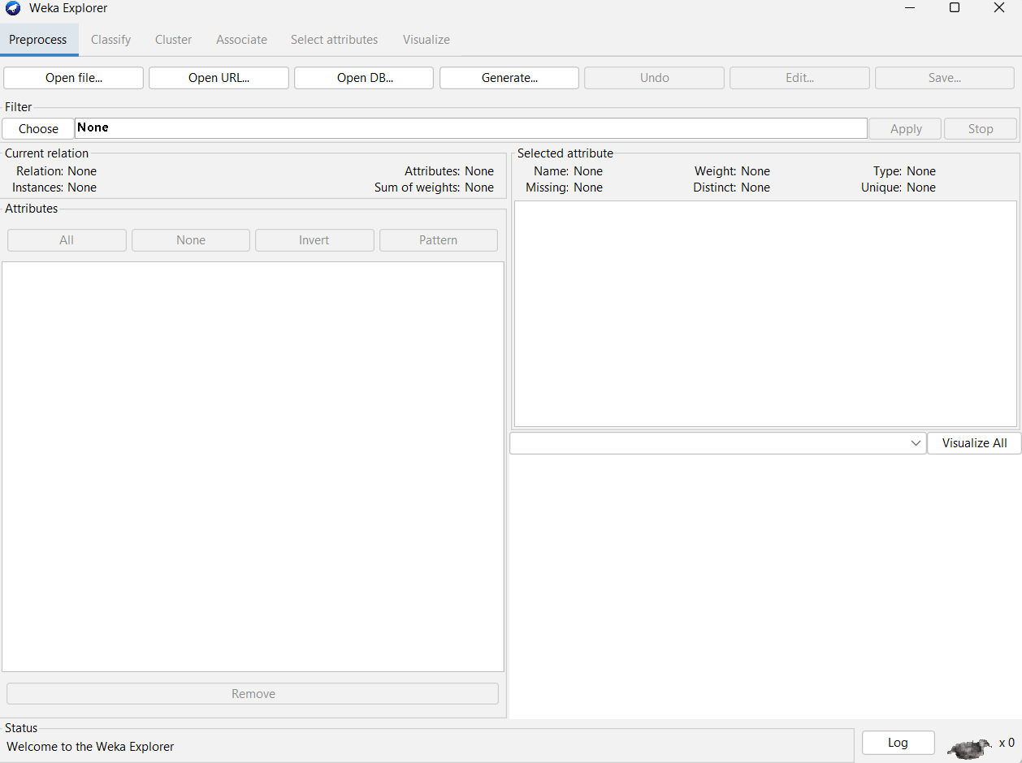

1. **Load Your Dataset**: Click on the "Open file" button and select your dataset file.

**Open file\windows c\program files\weka 3**.**9.6\data**

**Select the dataset your to explore and click open.**

**Now the dataset is loaded to explore.**

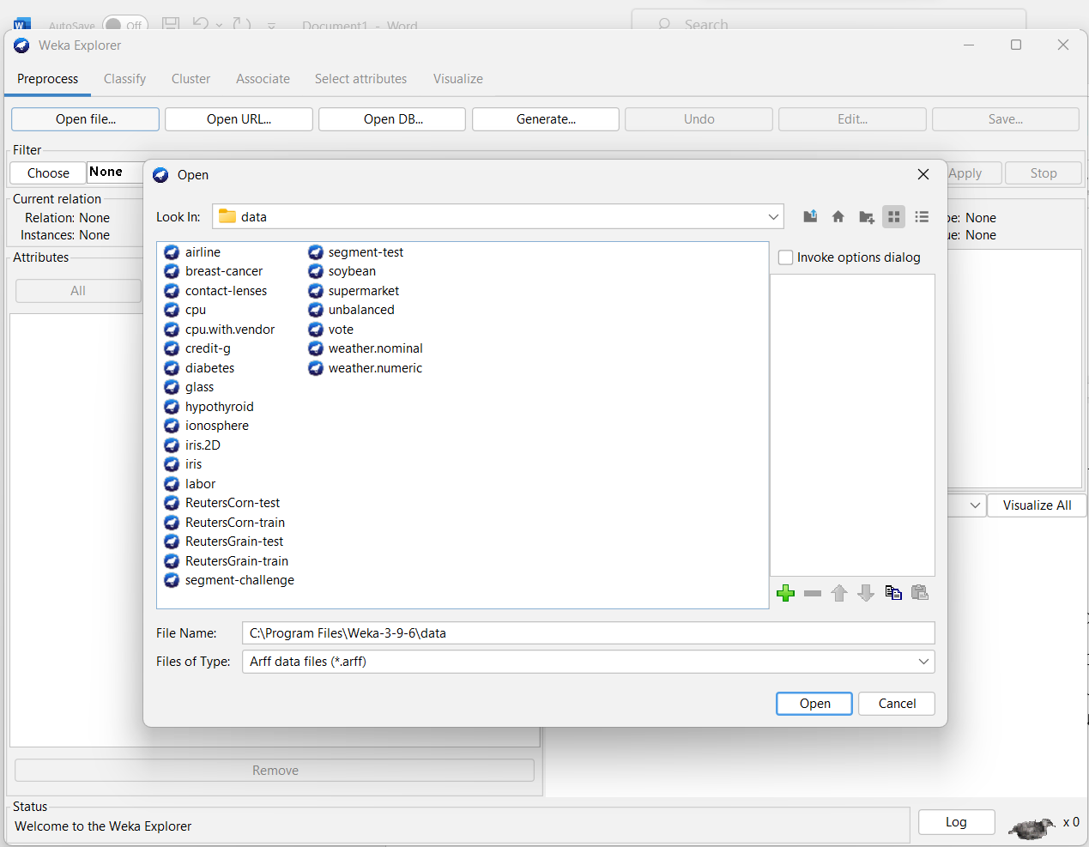

1. **Preprocess the Data**: Use the “Preprocess” tab to clean and prepare your data. Apply filters and select attributes as needed.

**Choose/weka/filter/apply**

In filter ,there will be allfiter,multifilter**,**rename relation,supervised,unsupervised

From this we choose the filter we to apply for the datasets

Here we can handle the missing value and prepare the datasets for better accuracy.

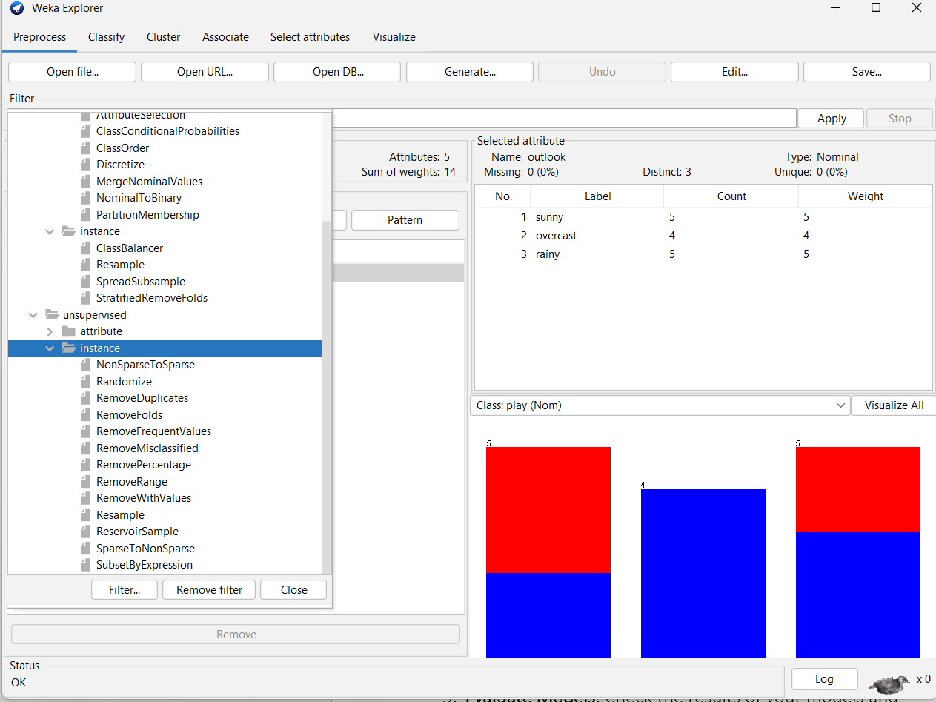

1. **Apply Algorithms**: Switch to the "Classify" tab for classification, "Cluster" tab for clustering, "Associate" tab for association rules, or "Regression" tab for regression. Select the algorithms you want to use and configure their parameters.

Classify/choose/algorithm/start.

Here we can choose the algorithm to implement.

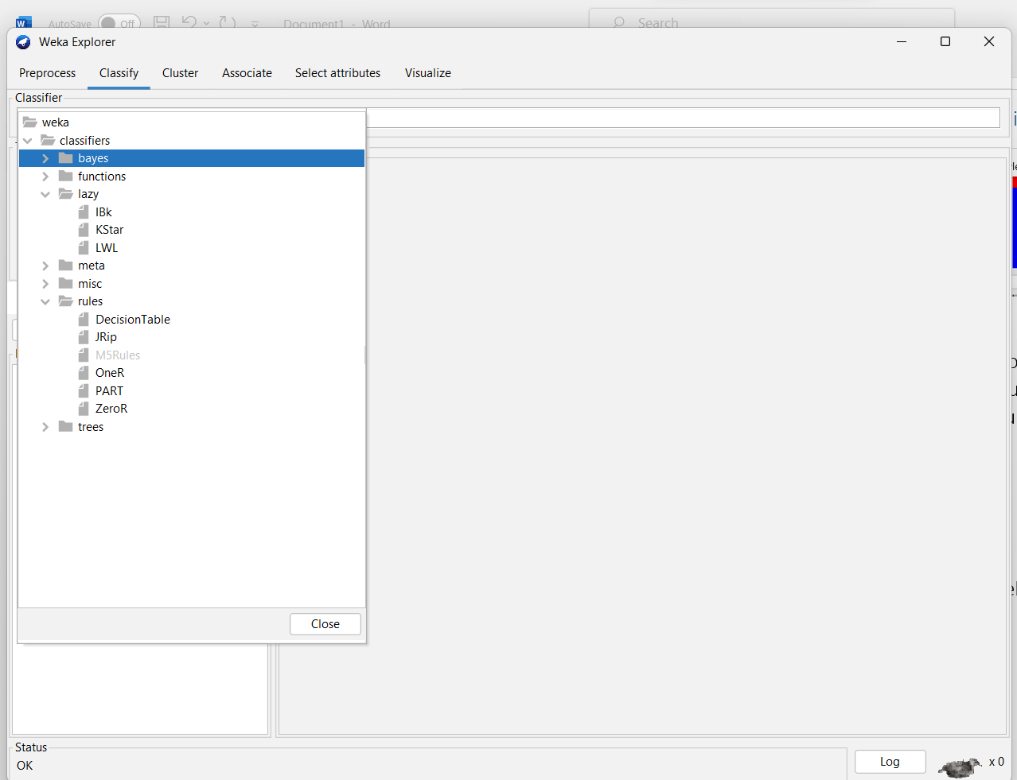

1. **Evaluate Models**: Check the results of your models and evaluations. Use the “Result list” to compare different models and their performance metrics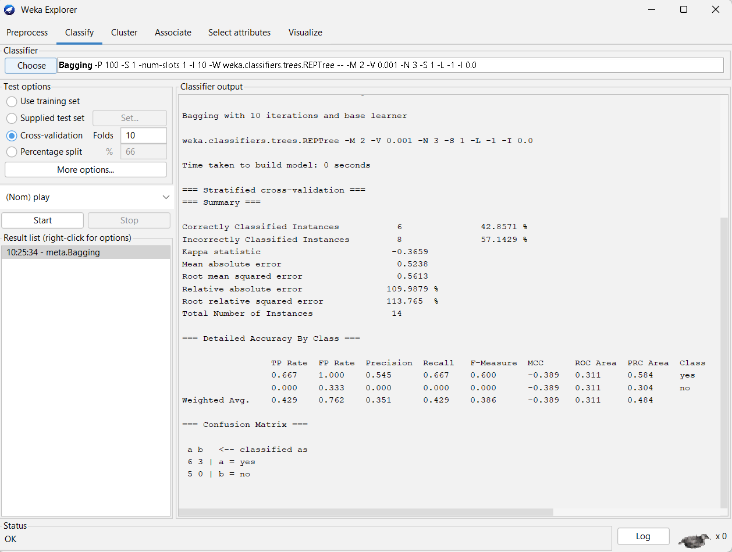.
2. **Visualize Data**: Use the “Visualize” tab to create and view different plots and charts.

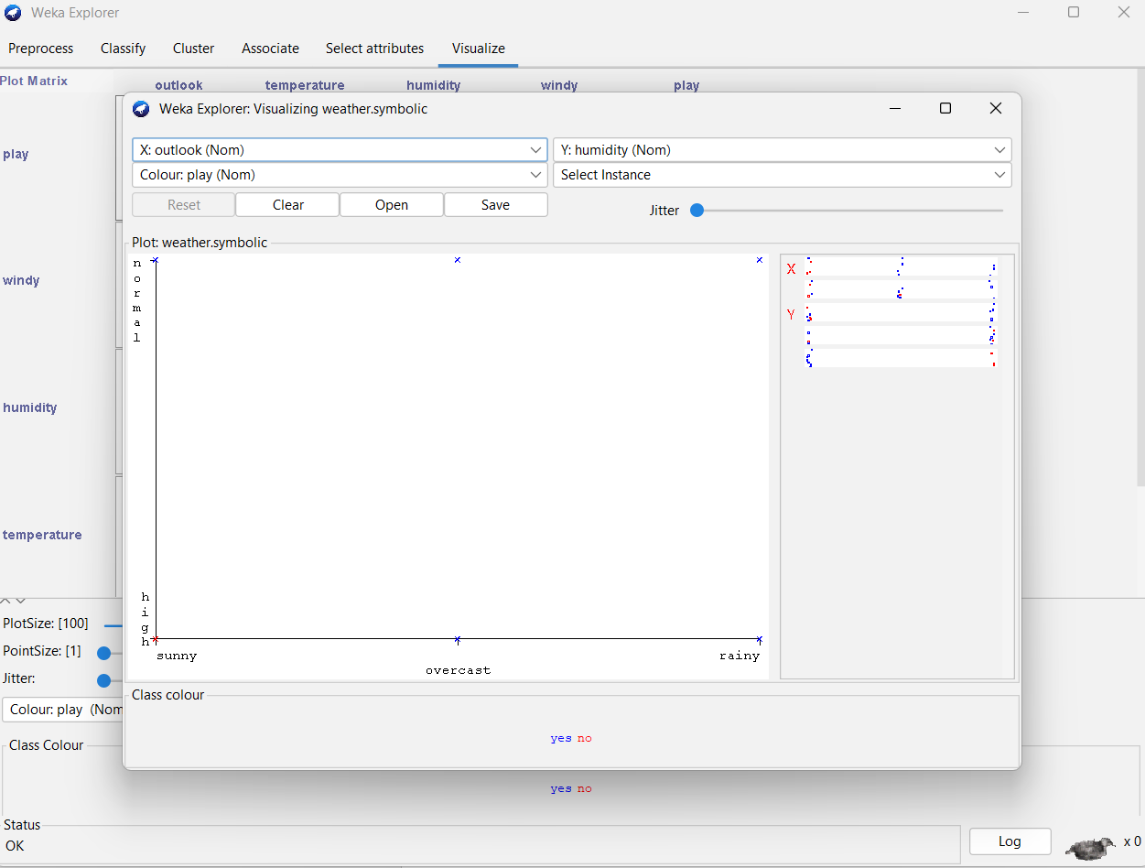

EXPERIMENTER IN WEKA

The **Experimenter** in Weka is a powerful tool designed for conducting systematic experiments and evaluating machine learning models. It allows you to compare different algorithms, configurations, and settings in a structured way.

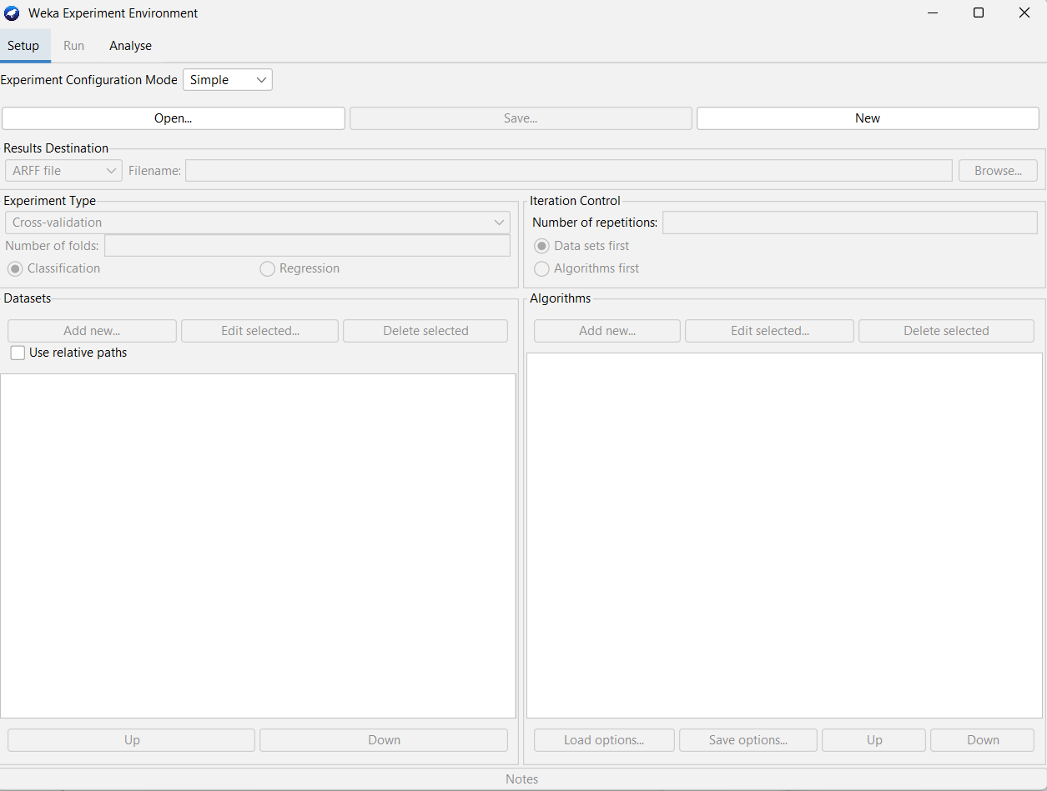

**Step 1: Open the Experimenter**

1. **Launch Weka** and select the **Experimenter** interface from the Weka GUI chooser.

**Step 2: Set Up an Experiment**

1. **Create a New Experiment**:
   * Click on the **“New”** button to start a new experiment setup.

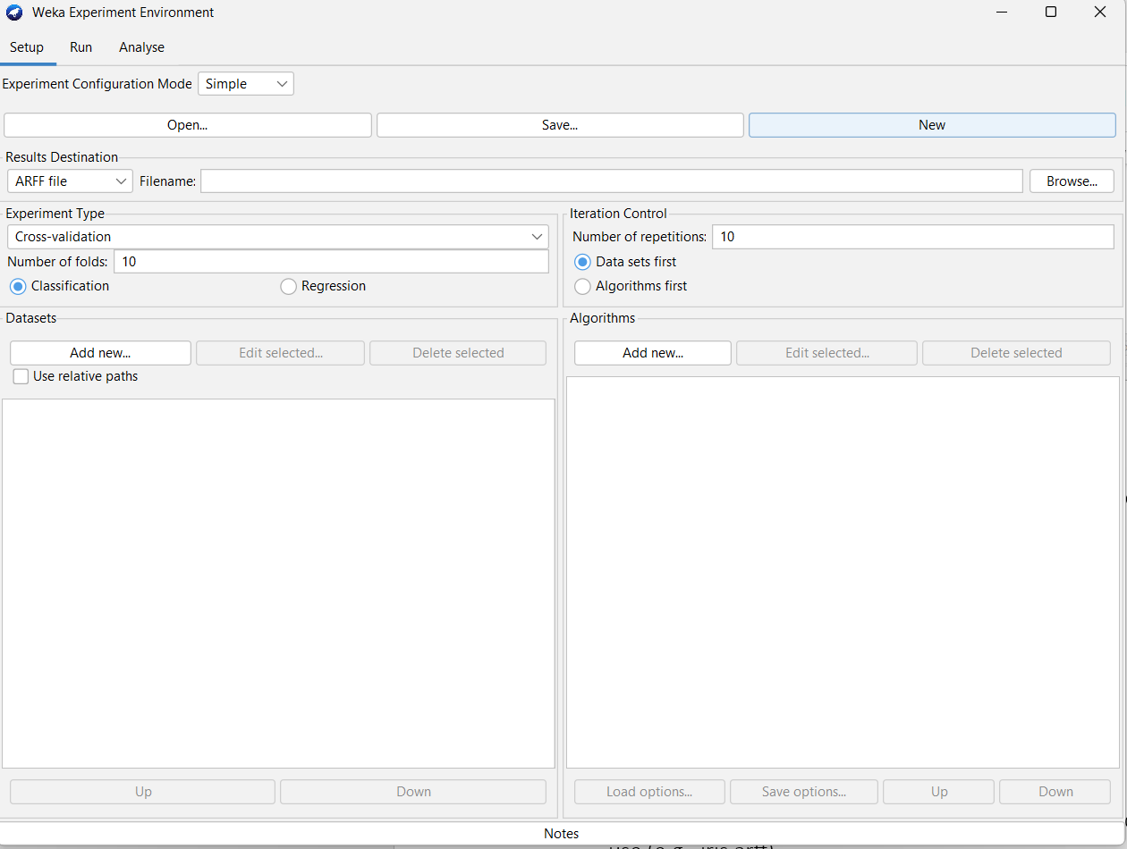

1. **Define Datasets**:
   * Go to the **“Datasets”** tab.
   * Click **“Open”** to select and load the dataset you want to use (e.g., iris.arff)
   * **Add new/data/datasets/open.**

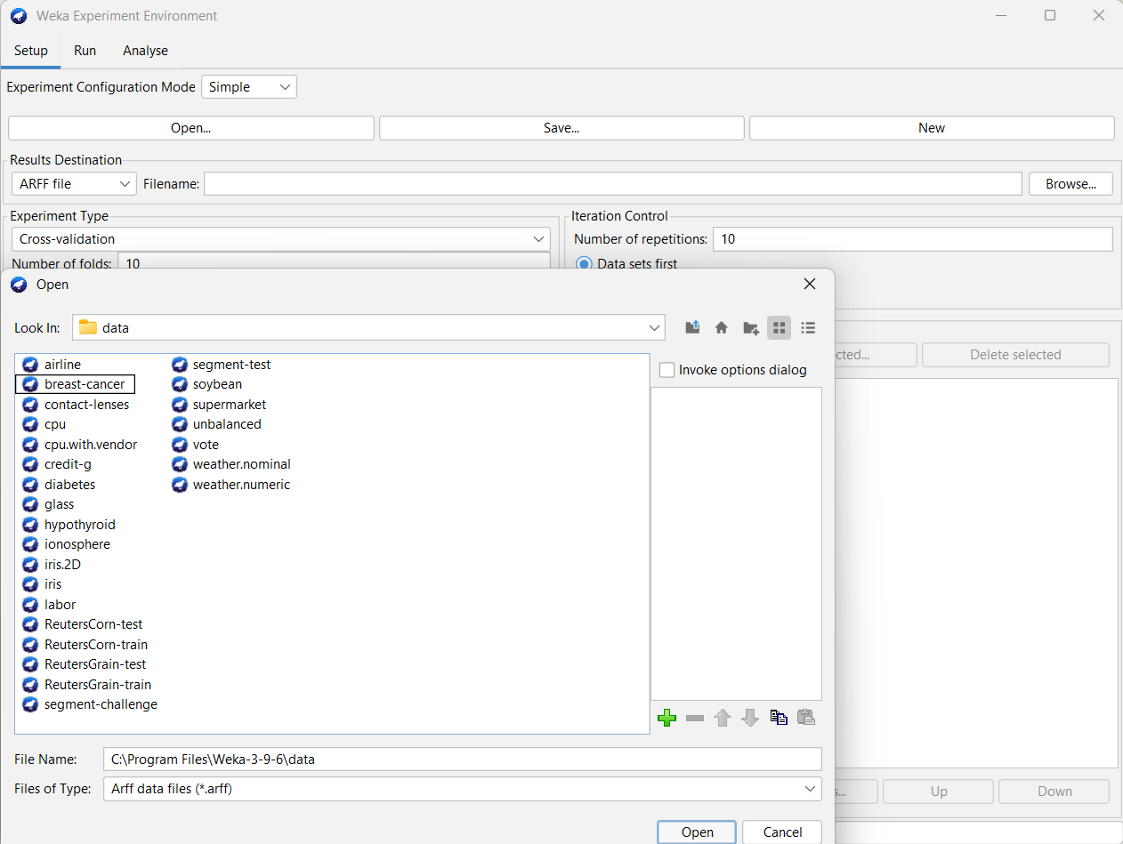

Choose the dataset we use

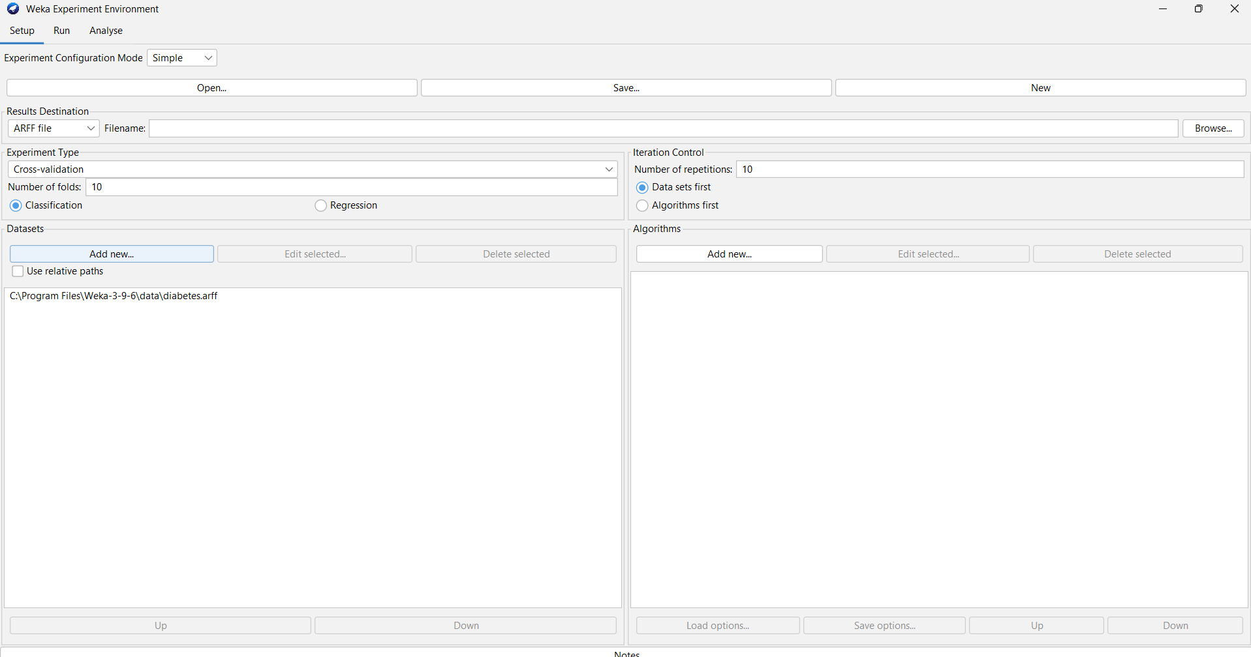

1. **Choose Algorithms**:
   * Go to the **“Algorithms”** tab.
   * Click **“Add”** to include algorithms for comparison. For example, add:
     + **J48** (Decision Tree)
     + **Naive Bayes**
     + **Support Vector Machine (SMO)**

**Algorithm/add new/choose/algorithm/ok**

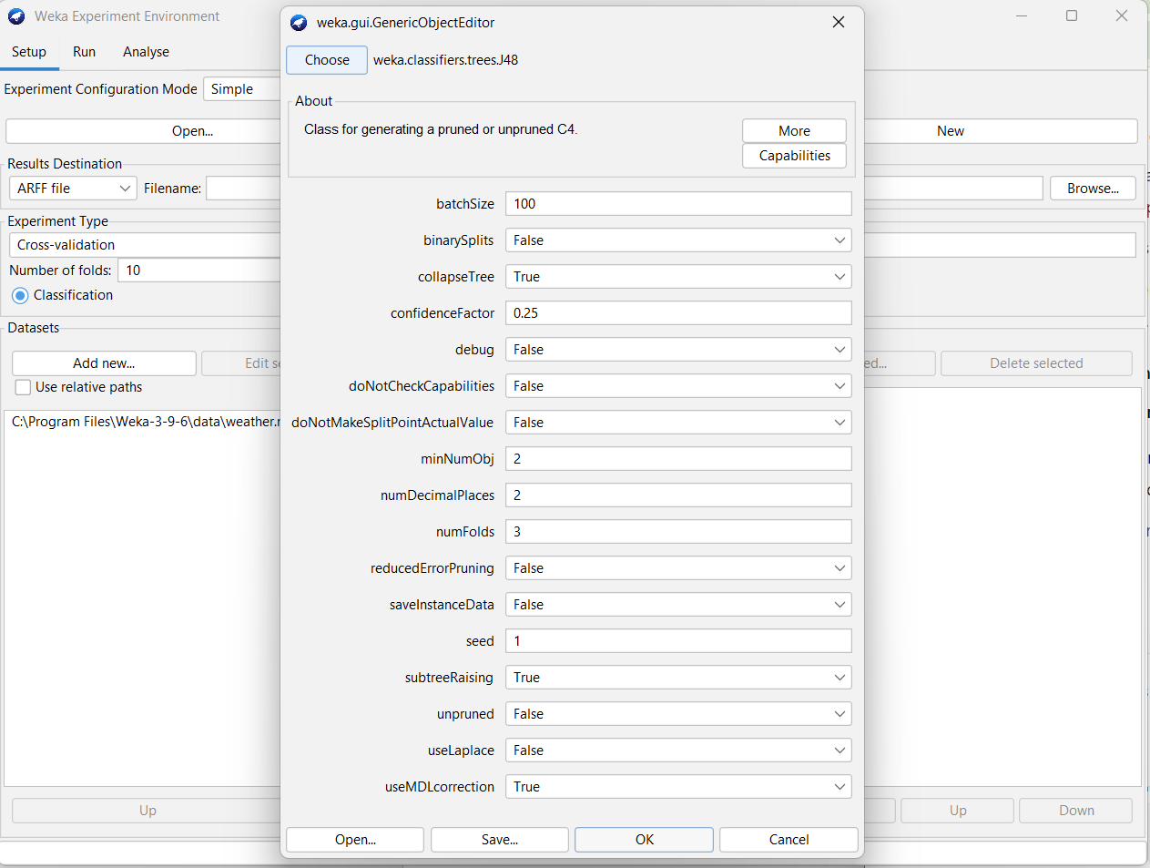

Choose the algorithms we need to apply and click ok

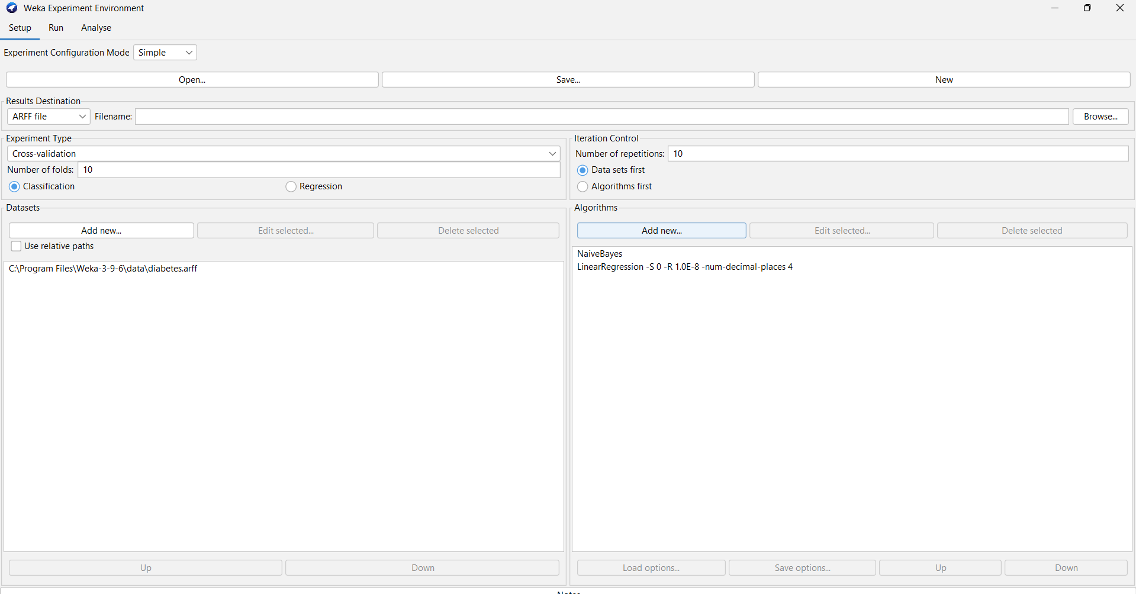

1. **Set Evaluation Methods**:
   * Go to the **“Evaluation”** tab.
   * Choose the evaluation method, such as **cross-validation** (e.g., 10-fold cross-validation) or a percentage split (e.g., 70% training and 30% testing).

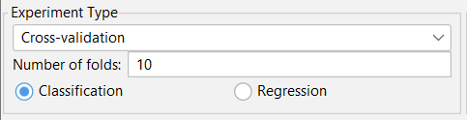

1. **Configure Parameters**:
   * Set parameters for the algorithms if needed. For instance, adjust settings for the SMO or J48 algorithms.

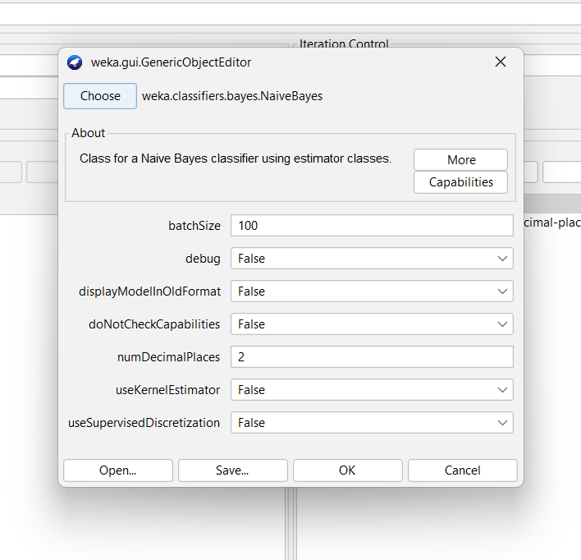

**Step 3: Run the Experiment**

1. **Execute the Experiment**:
   * Click **“Start”** to run the experiment. Weka will process each algorithm and evaluation method as defined.
   * Monitor the progress and check for any issues during execution.

Run tab/start.

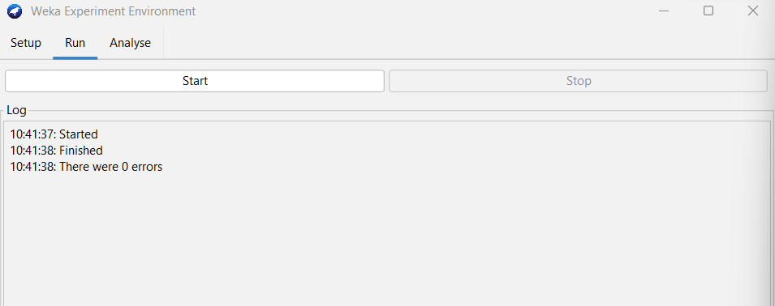

**Step 4: Analyze Results**

1. **View Results**:
   * After completion, go to the **“Results”** tab.
   * Review performance metrics such as accuracy, precision, recall, F-measure, and others.
   * Analyse/experiment/perform test
   * To do ranking in the algorithm

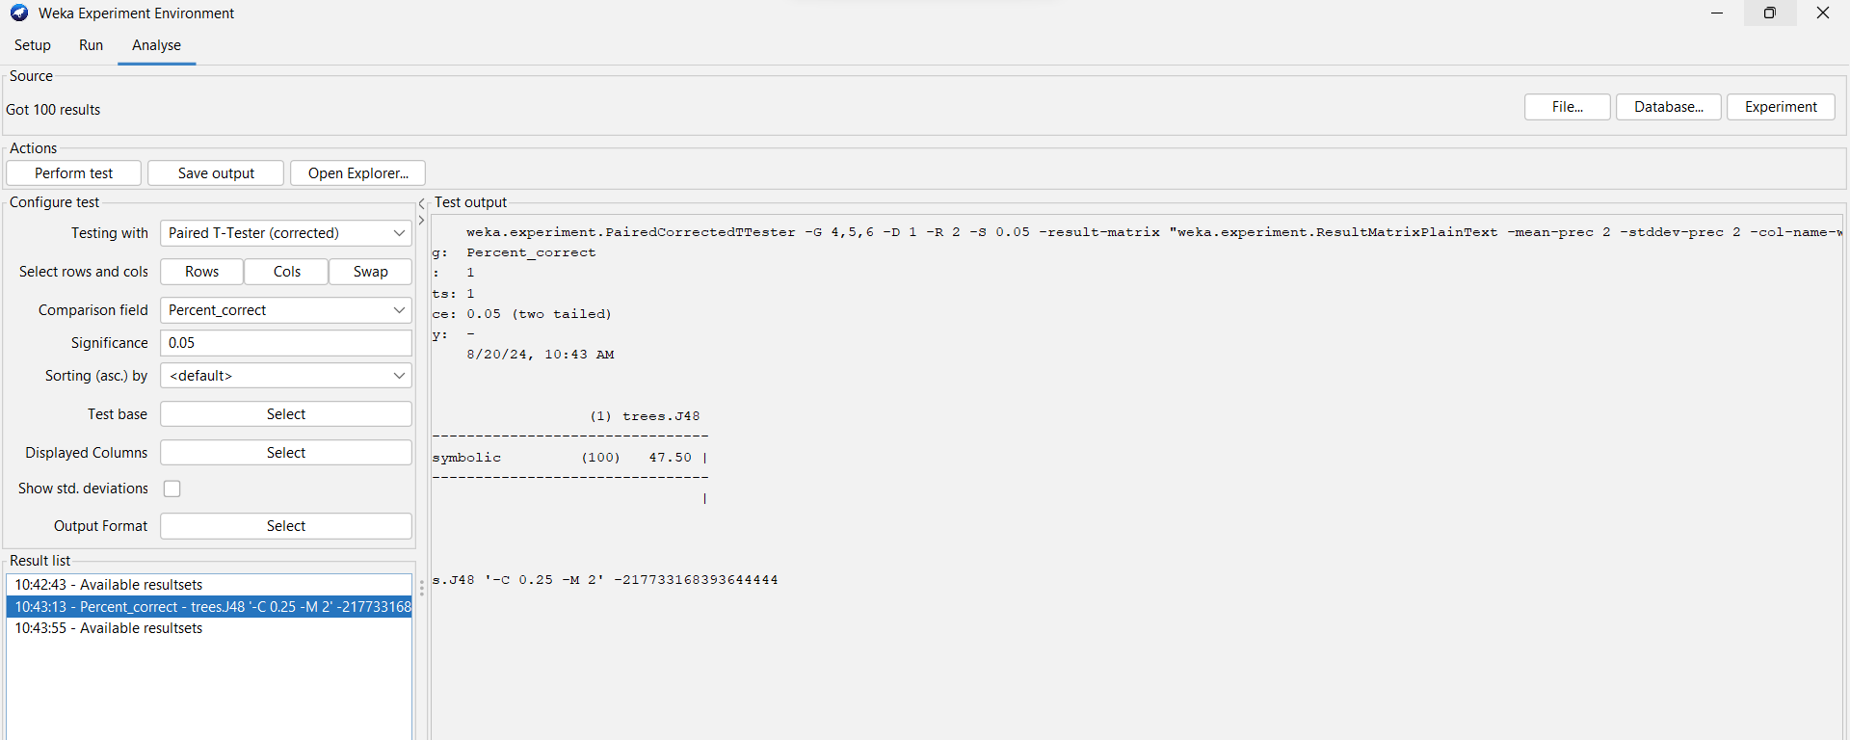

Compare the alorithms.

Test base/select/ranking/select/perform test.

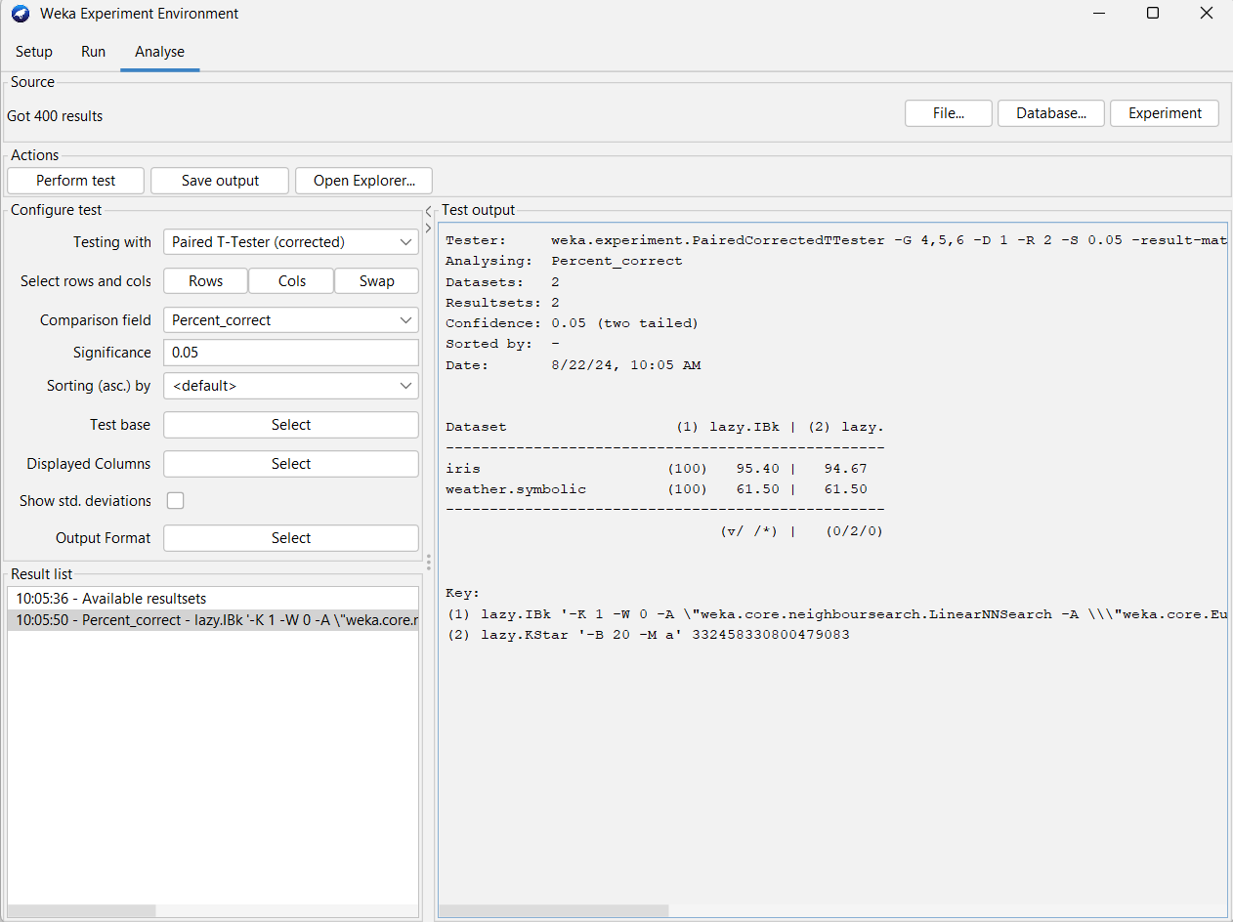

**Step 5: Save and Export**

1. **Save Experiment Settings and Results**:
   * Save your experiment setup and results for future reference or sharing.
   * Click **“Save”** in the **“Output”** tab.



KNOWLEDGEFLOW IN WEKA

Knowledge Flow is a visual interface in Weka that allows users to design and execute machine learning workflows interactively. It provides a more visual approach to building data processing and analysis pipelines compared to the more traditional GUI-based interactions found in Weka's other interfaces like the Explorer or Experimenter.

Step 1: Open Knowledge Flow

1. Launch Weka: Open Weka from your desktop or start menu.
2. Select Knowledge Flow: From the Weka GUI chooser, select the Knowledge Flow interface.

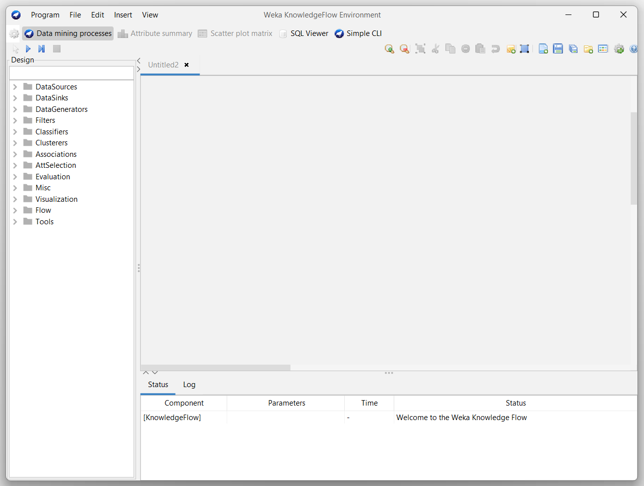

Step 2: Design a Workflow

1. Create a New Workflow:
   * Drag Components: From the component palette (usually on the left side), drag data source components (e.g., FileLoader) to the canvas.

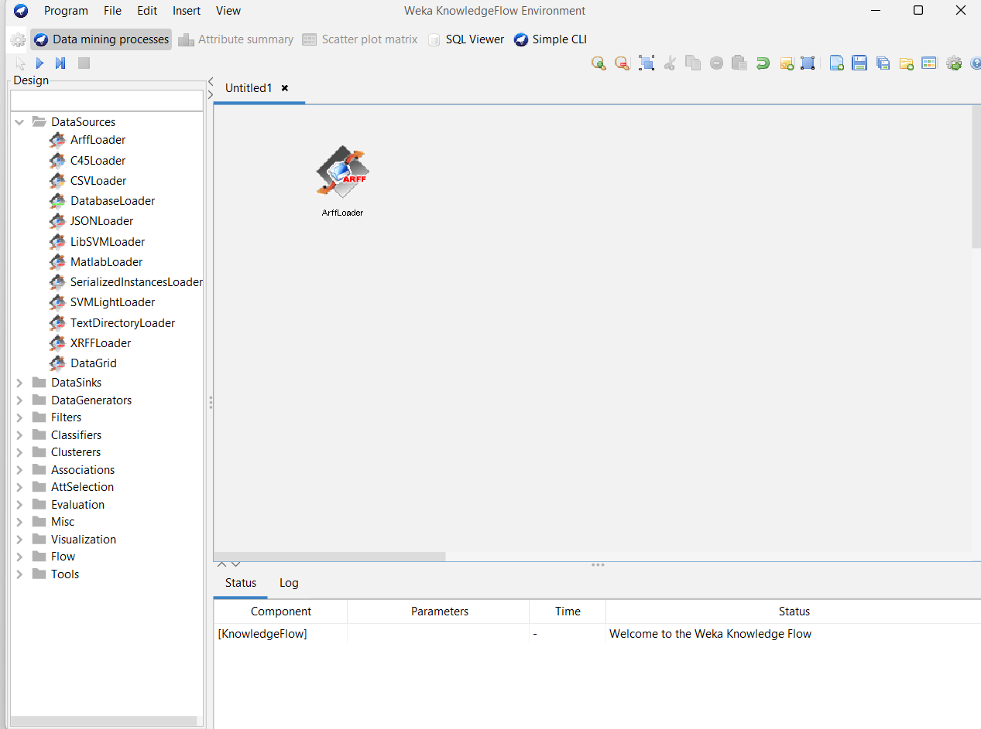

* + Add Classifiers: Add machine learning algorithms (e.g., J48, SMO) for modeling.

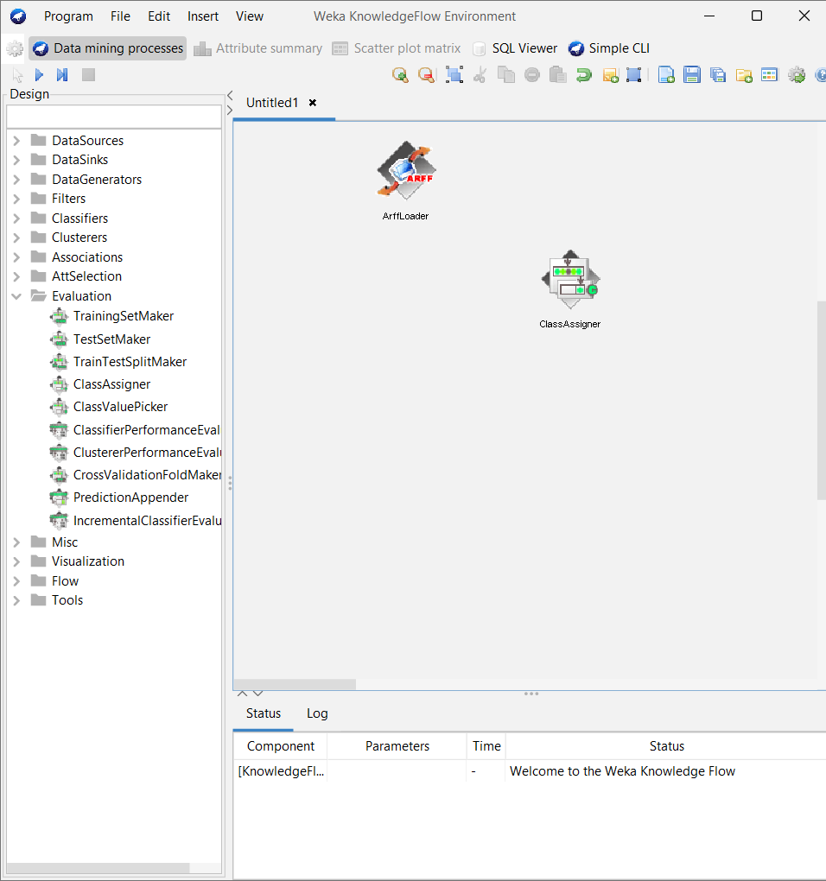

* + Add Evaluators: Include evaluators (e.g., CrossValidation, TestSet) to assess model performance.

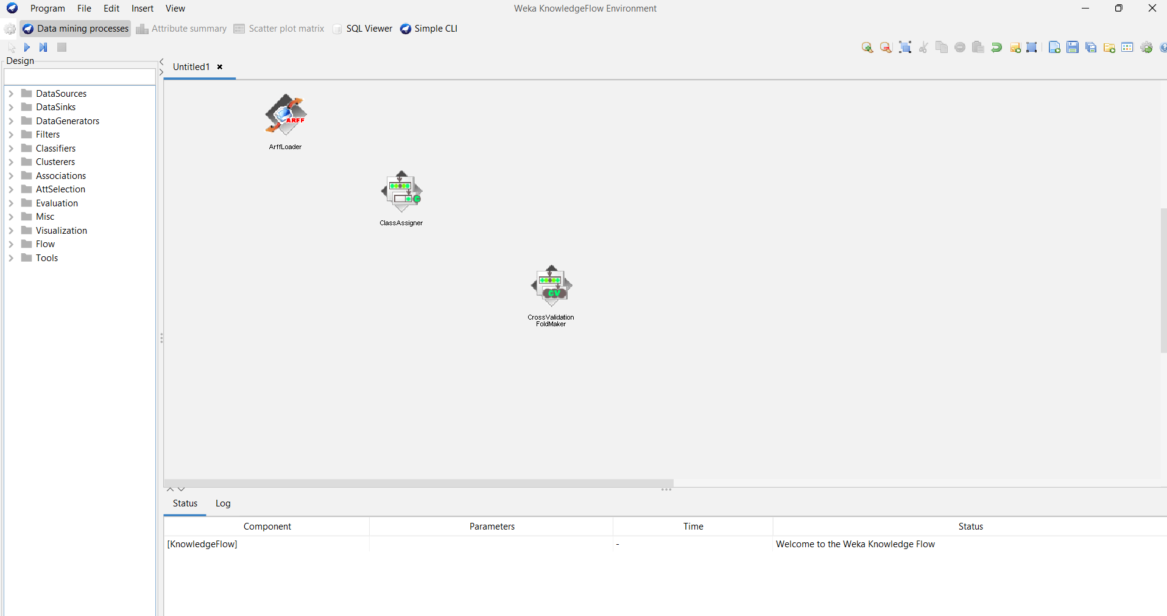

Add algorithm: Add algorithm to perform the task

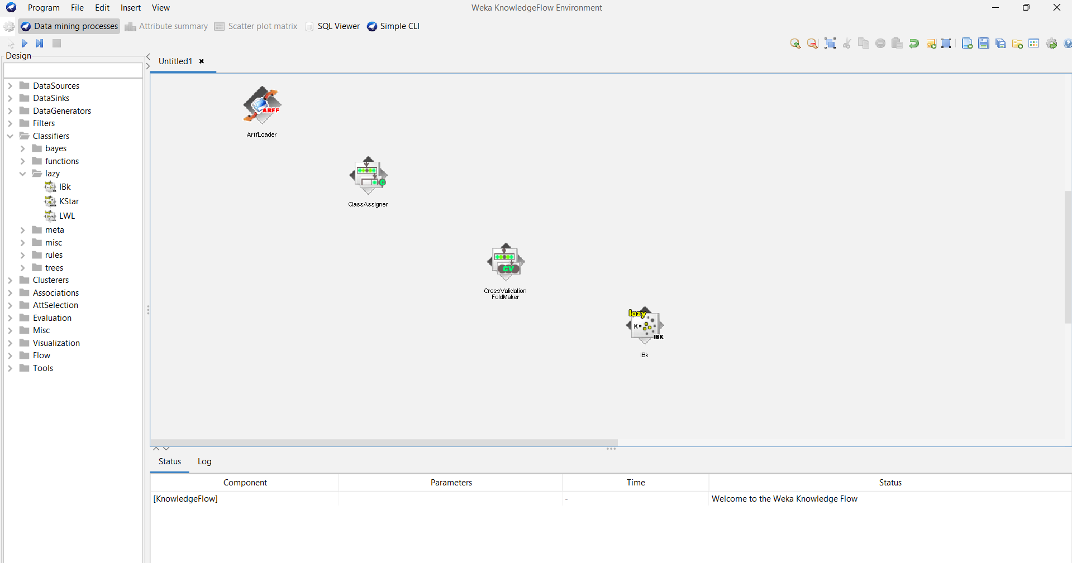

Add classifierperformanceevaluation

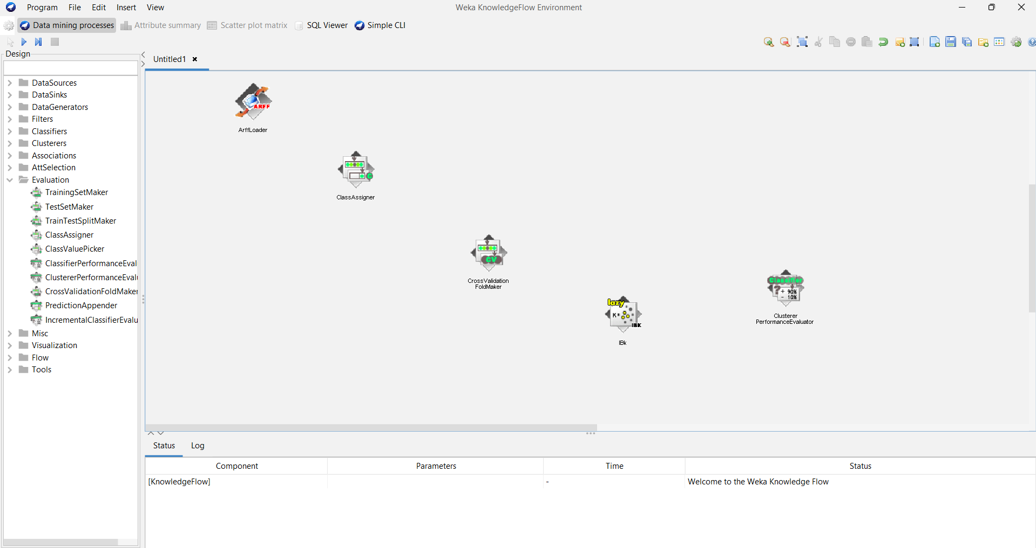

* + Add Visualizers: Add visualizers to create plots and charts for data analysis.

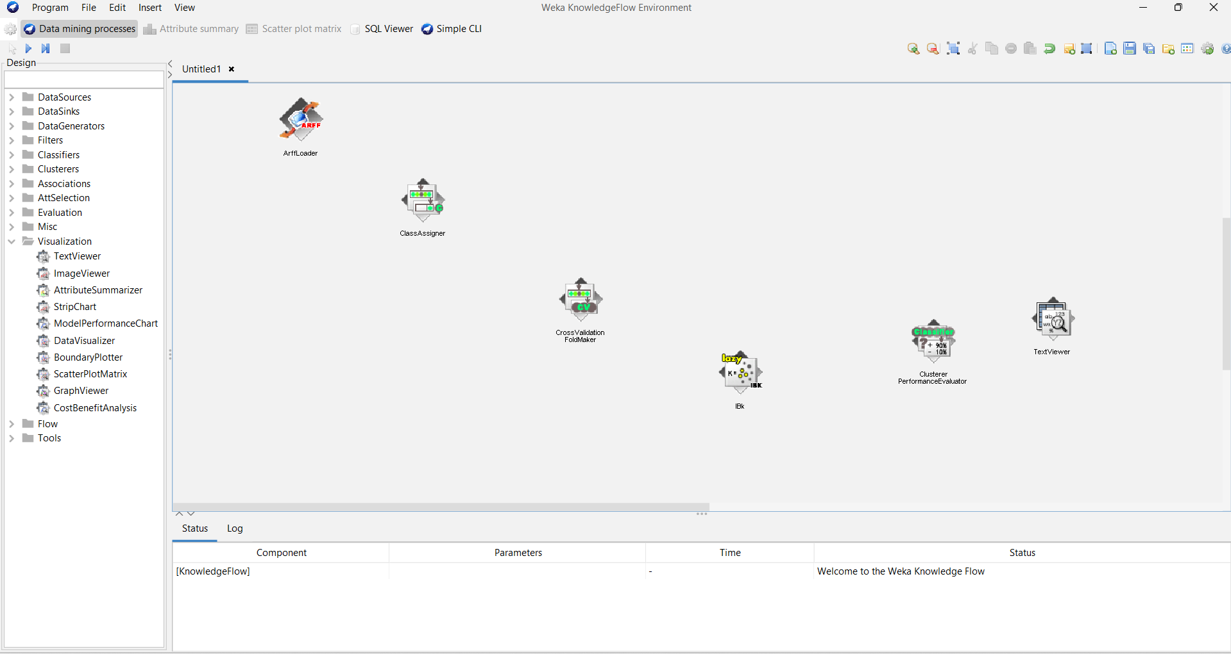

1. Connect Components:
   * Draw Connections: Click and drag from one component’s output port to another component’s input port to define the flow of data.

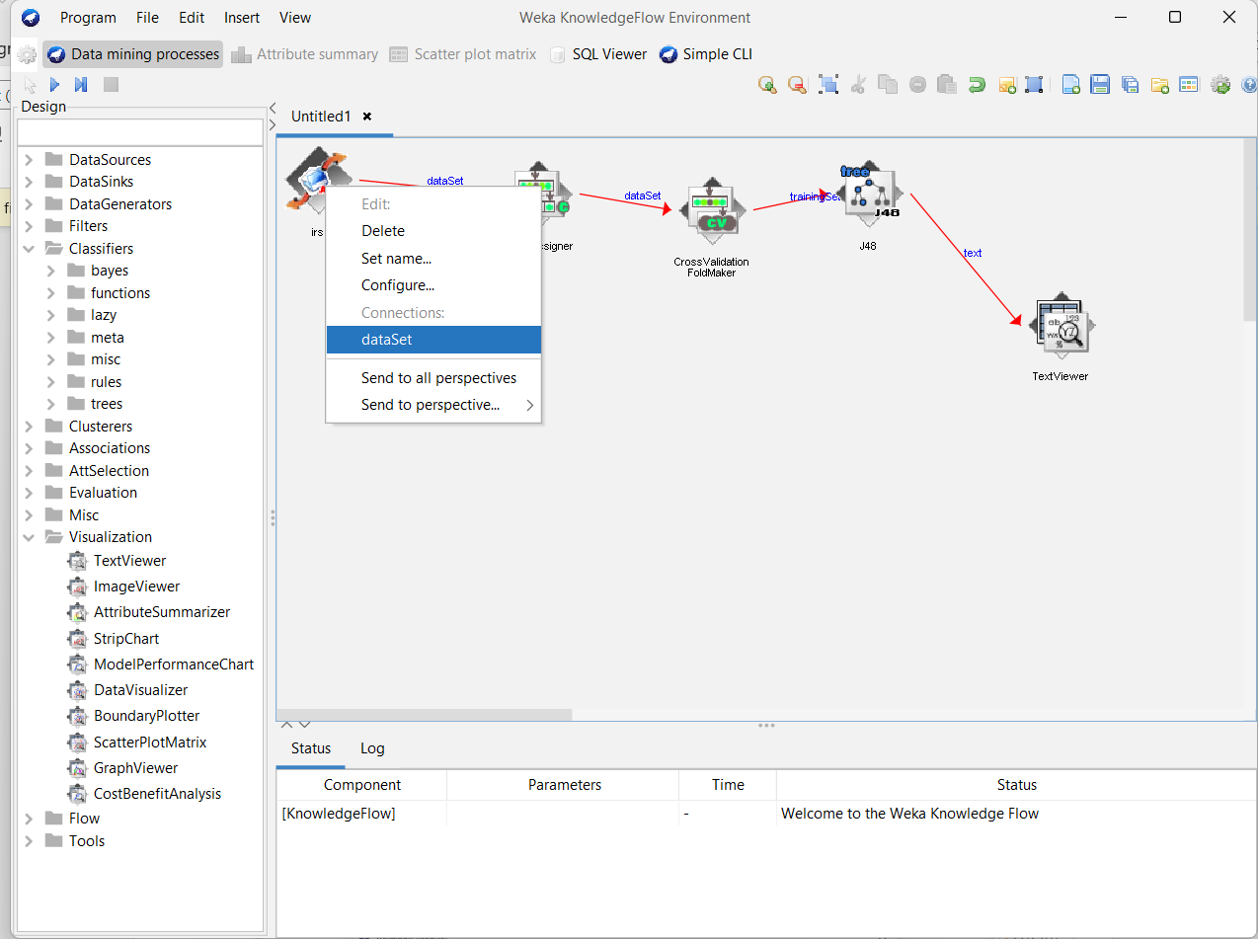

Step 3: Configure Components

1. Set Parameters:
   * Select a Component: Click on a component in the workflow.
   * Configure Settings: Use the configuration panel (usually on the right side) to set parameters for each component, such as file paths, algorithm settings, and evaluation options.

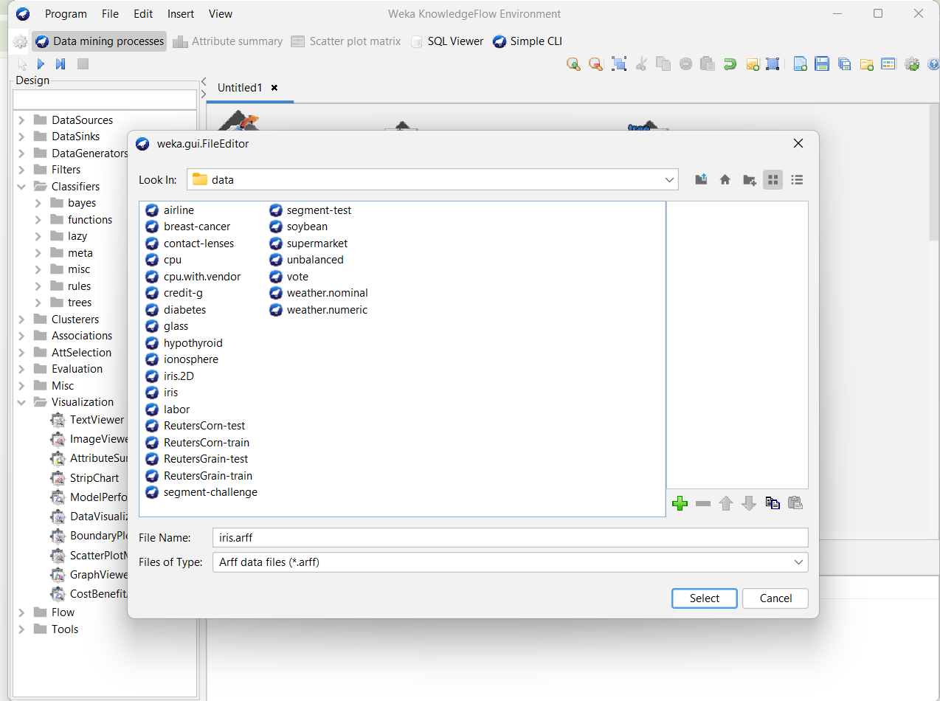

Step 4: Execute the Workflow

1. Run Workflow:
   * Start Execution: Click the “Run” button (or similar) to execute the workflow.
   * Monitor Progress: Observe the progress and results of each component as the workflow runs.

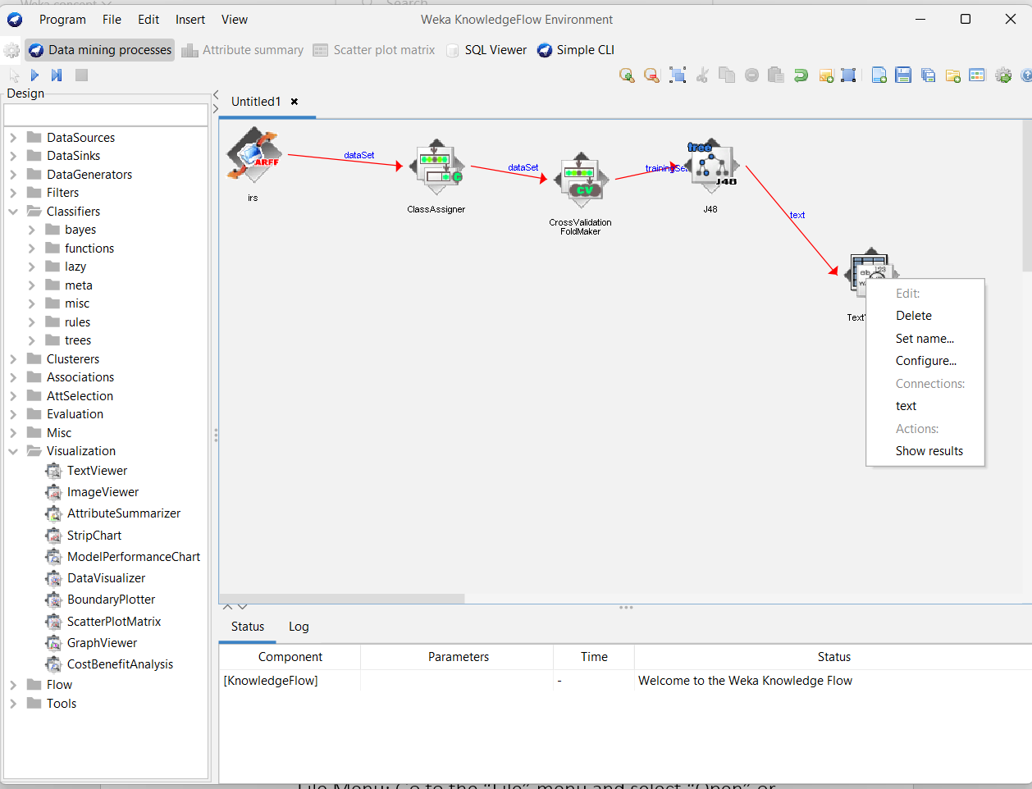

1. View Results:
   * Check Outputs: Review the results from the classifiers, evaluators, and visualizers.

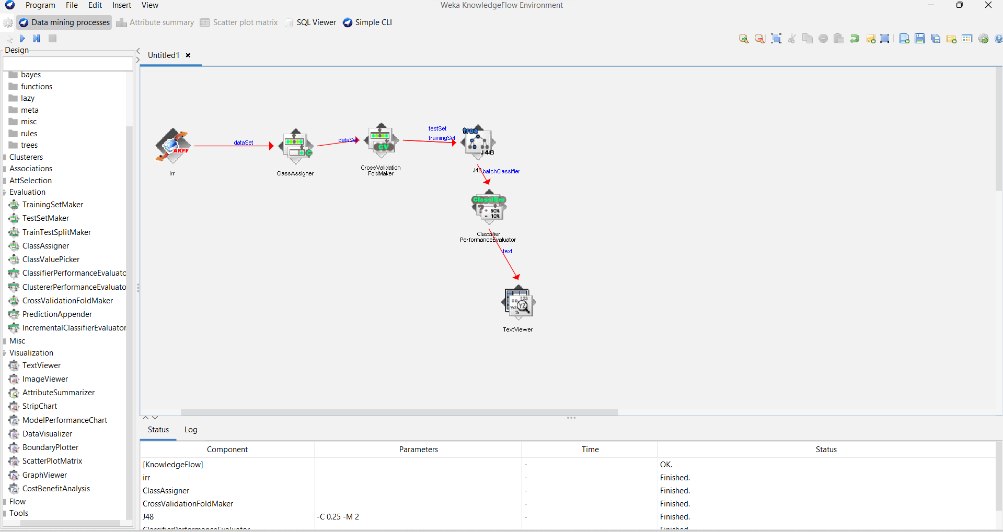

Right click the text view\show results

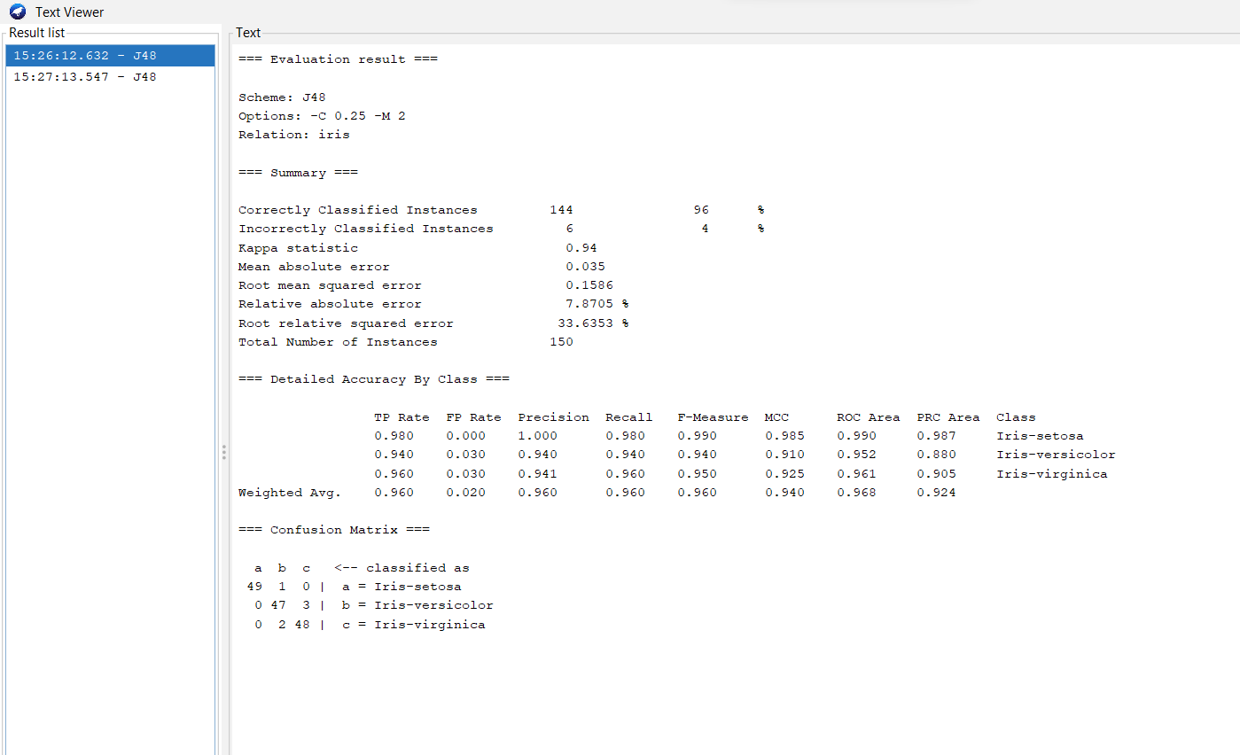

**Simple CLI**

Here we can perform algorithm using the command line

There is syntax to write command line

Java \algorithm to perform \dataset

-h is used to get help

-t for training dataset

-T fot testing dataset

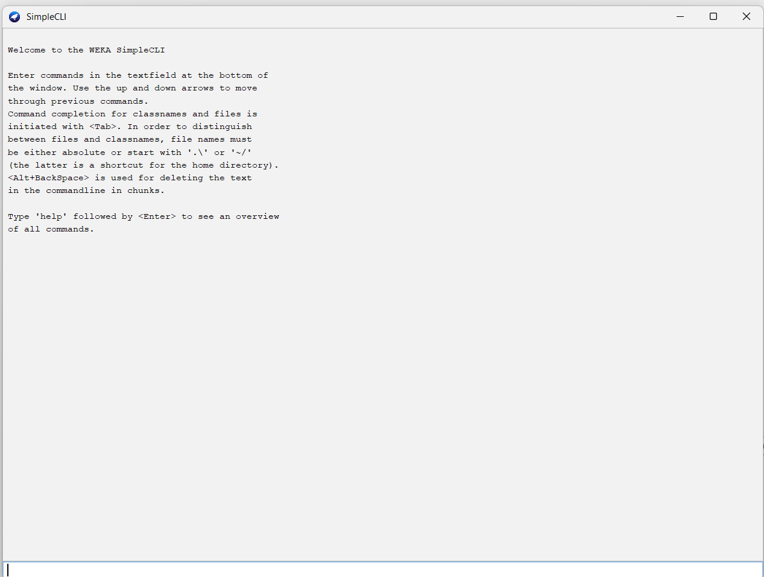

Sample command line:

java weka.classifiers.trees.J48 -C 0.25 -M 2 -t "C:\Program Files\Weka-3-9-6\data\iris.arff"

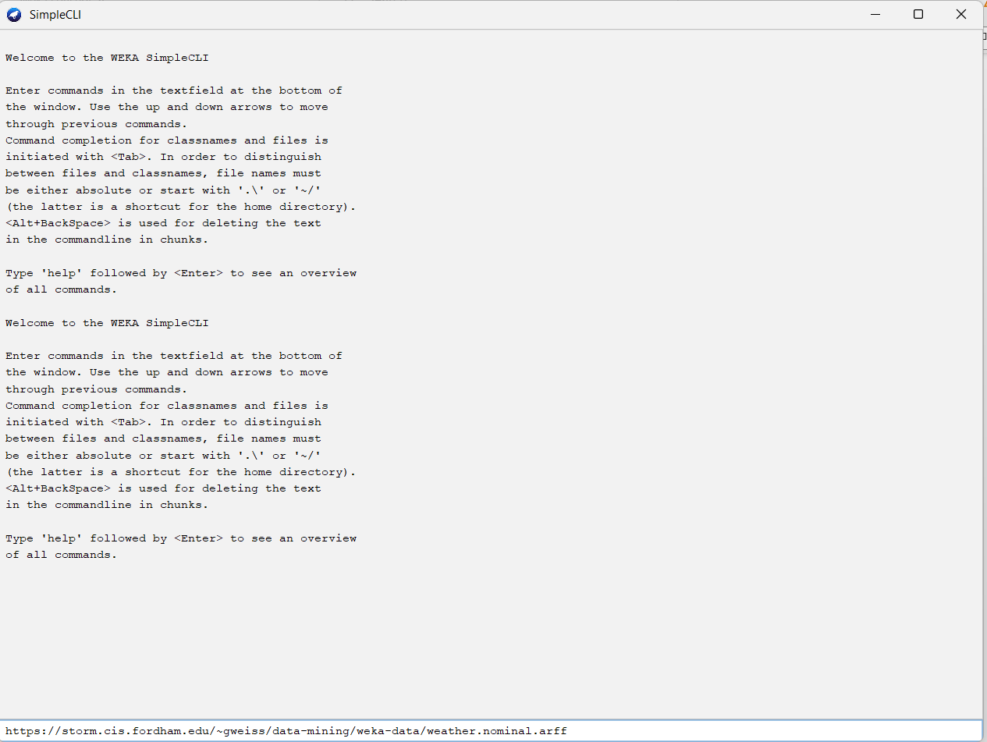

Click enter to run the command line

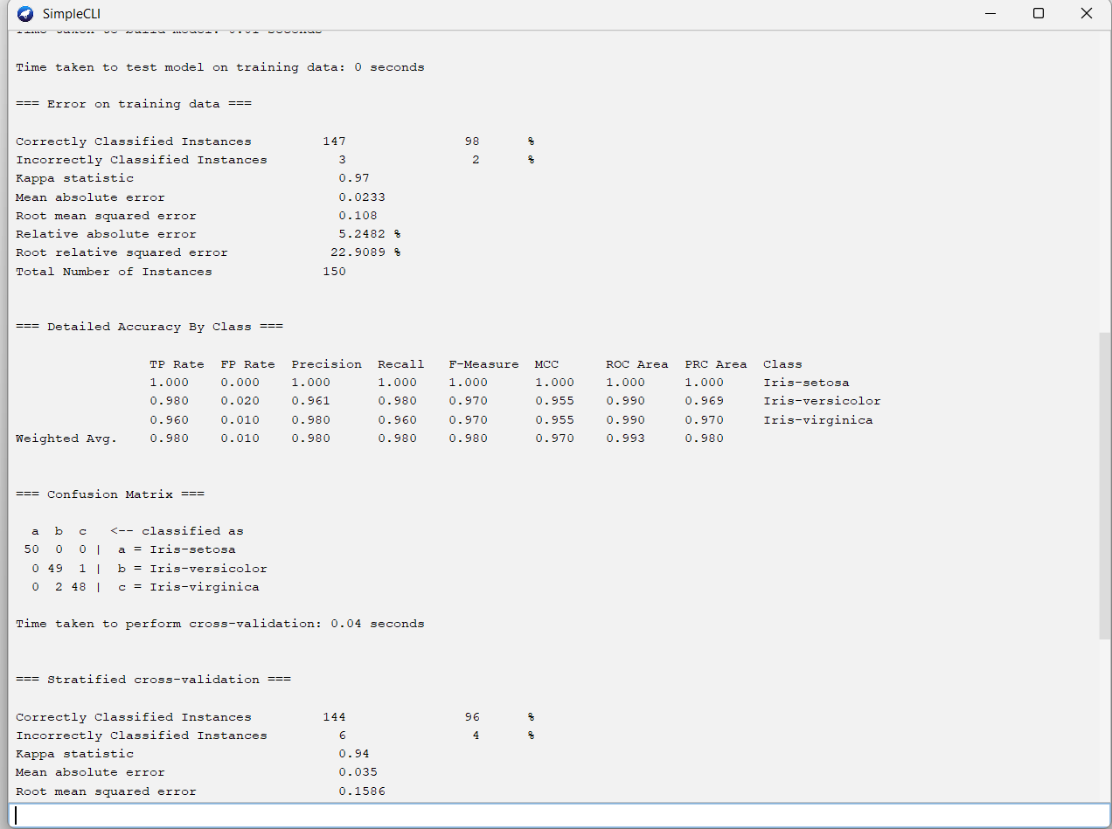

Workbrench:

The **Workbench** is the main graphical user interface (GUI) that provides access to various machine learning tools and functionalities. It allows users to perform tasks such as data preprocessing, classification, regression, clustering, and visualization.

Here explorer, experimenter ,knowledgeflow ,simple CLI can be performed

